Warrior Run Fire Company Offers Community Service Assistance
Watsontown, PA-
The Warrior Run Fire Company recently offered community service assistance to Kingdom Kidz Inc. at their building (11 E. 3rd St., Watsontown). After the Warrior Run National Art Honor Society completed a sign for the Kingdom Kidz’ nonprofit organization, the staff realized that a ladder much higher than what they had was needed to hang the sign. When Fire Chief, Doug Funk, was contacted, the solution was to bring their newly purchased aerial ladder truck. With the assistance of 2 firemen (Ken Hollenbach and Brian Bryson) the sign was hung in December.
For more information about Kingdom Kidz Inc. and their programs, contact Donna Bridge, General Manager, or Lisa Derr, Team/Program Director at 570-838-3133 or visit www.hiskingdomkidz.org.
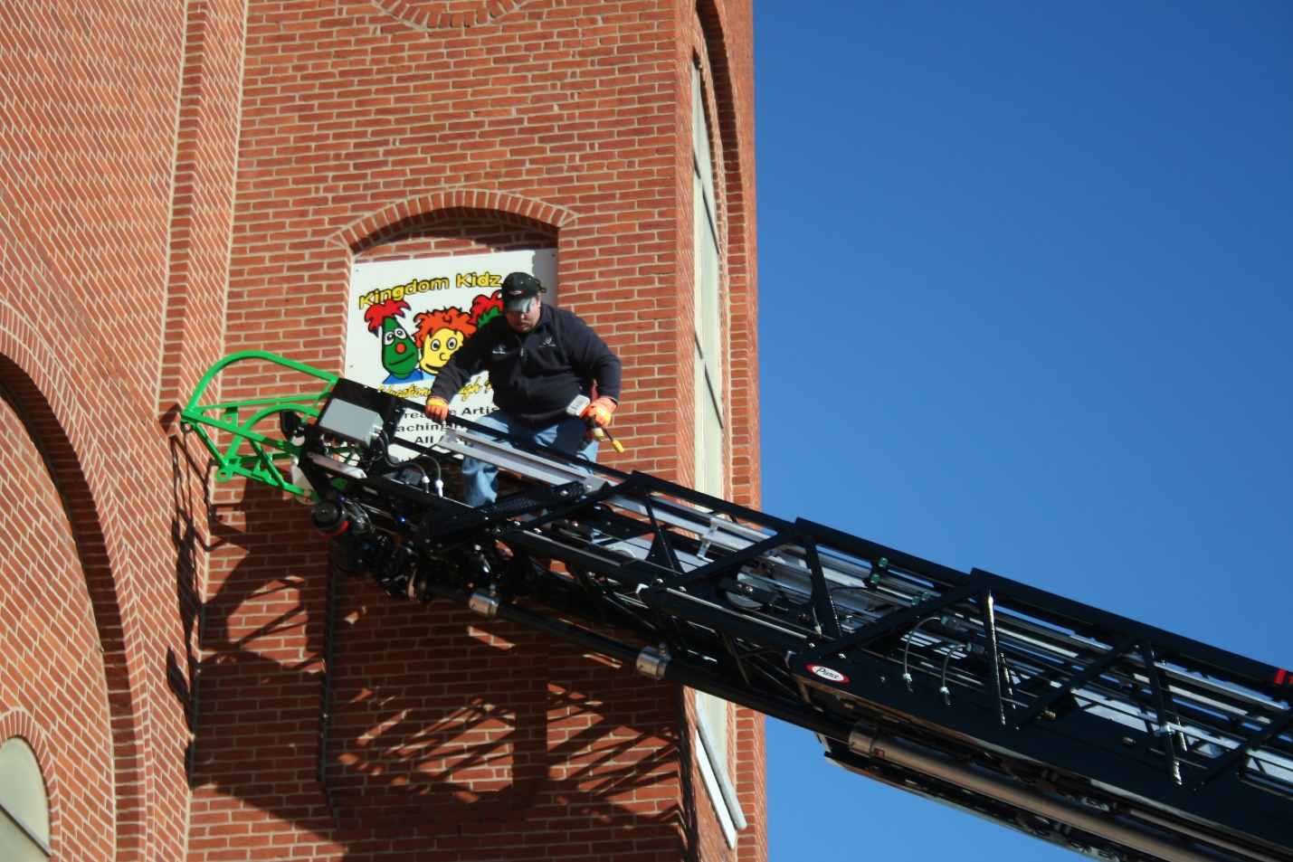
Shown hanging the sign is Ken Hollenbach
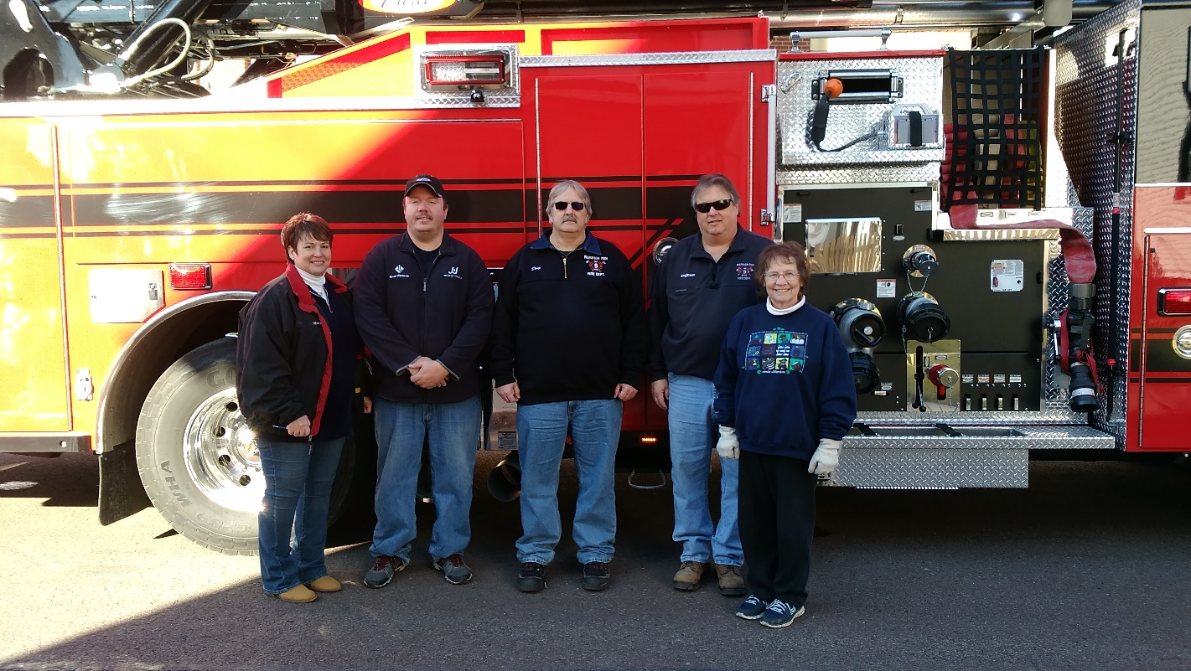
Shown beside the aerial ladder truck are Lisa Derr (Team/Program Director), Ken Hollenbach, Doug Funk, Brian Bryson and Donna Bridge (General Manager)
# # # #

